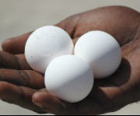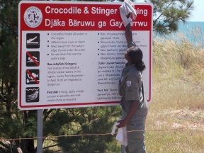
VOLUNTEER WITH DHIMURRU
Please complete and return to permits@dhimurru.com.au

Name: …………………...…………………………………………………………. DOB: …………………………………………………………………..

Address: …………………………………………………………………………………………………………………………………………………………………
………………………………………………………………………………………………………………………………………………………………………………..

Availability:………………………………………………………………………………………………………………………………………………………….

Why would you like to volunteer with Dhimurru? ………………………………………………………………………………………….........
……………………………………………………………………………………………………………………………………………………………………………….
……………………………………………………………………………………………………………………………………………………………………………
………………………………………………………………………………………………………………………………………………………………………………

Interests:………………………………………………………………………………………………………………………………………………………………………
……………………………………………………………………………………………………………………………………………………………………………………
…………………………………………………………………………………………………………………………………………………………………………………….

Relevant qualifications/experience: …………………………………………………………………………………………………………………………
…………………………………………………………………………………………………………………………………………………………………………………
………………………………………………………………………………………………………………………………………………………………………………….

Contact details: …………………………………………………………………………………………………………………………………………………………

